1.Create 2 activity from the first activity on a button click move to the second activity.

**Program**

activity_main.xml

**LinearLayout android:layout_width="match_parent" android:layout_height="match_parent"**

**android:orientation="vertical"**

**android:gravity="center"**

**xmlns:android="http://schemas.android.com/apk/res/android"**>

<**Button**

**android:layout_width="wrap_content"**

**android:layout_height="wrap_content"**

**android:text="MOVE TO NEXT ACTIVITY"**

**android:id="@+id/bt"**

**android:onClick="click"**

**android:gravity="center"**/>

</**LinearLayout**>

activity_main2.xml

<**LinearLayout android:layout_width="match_parent" android:layout_height="match_parent"**

**android:orientation="vertical"**

**android:gravity="center"**

**android:background="@android:color/holo_blue_light"**

**xmlns:android="http://schemas.android.com/apk/res/android"**>

<**TextView**

**android:layout_width="wrap_content"**

**android:layout_height="wrap_content"**

**android:text="WELCOME TO THE SECOND ACTIVITY"**

**android:id="@+id/tv"** />

</**LinearLayout**>

Java

mainActivity.java

**package** com.example.sjcet.cycle2_1;

**import** android.content.Intent;

**import** android.widget.Button;

**import** android.view.View;

**import** android.support.v7.app.AppCompatActivity;

**import** android.os.Bundle;

**public class** MainActivity **extends** AppCompatActivity {

Button **bt**;

**protected void** onCreate(Bundle savedInstanceState) {

**super**.onCreate(savedInstanceState);

setContentView(R.layout.***activity_main***);

**bt** =findViewById(R.id.***bt***);

}

**public void** click(View view) {

OpenNewActivity();

}

**public void** OpenNewActivity()

{

Intent intent=**new** Intent(**this**, Main2Activity.**class**);

startActivity(intent);

}

}

mainActivity2.java

**package** com.example.sjcet.cycle2_1;

**import** android.support.v7.app.AppCompatActivity;

**import** android.os.Bundle;

**public class** Main2Activity **extends** AppCompatActivity {

@Override

**protected void** onCreate(Bundle savedInstanceState) {

**super**.onCreate(savedInstanceState);

setContentView(R.layout.***activity_main2***);

}

}

**Output**

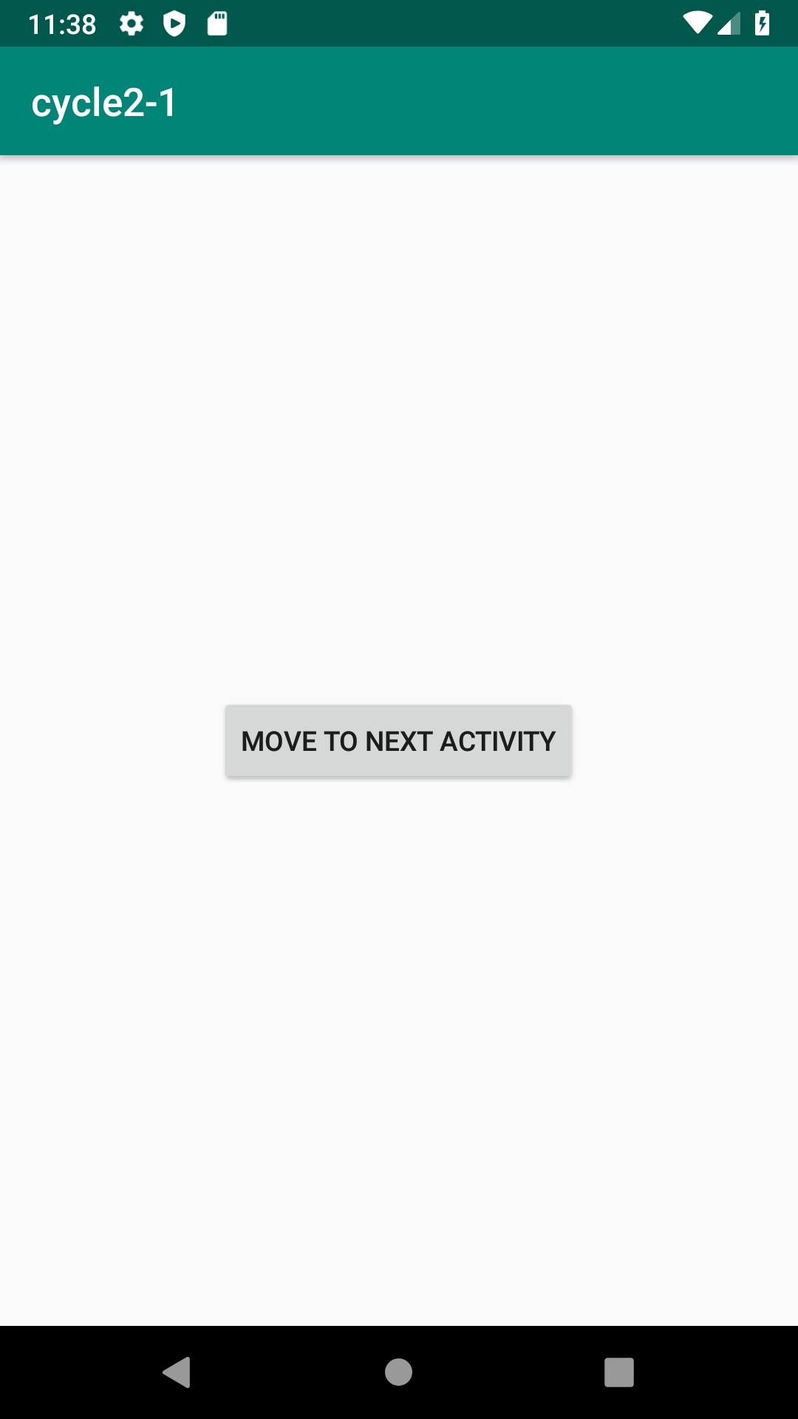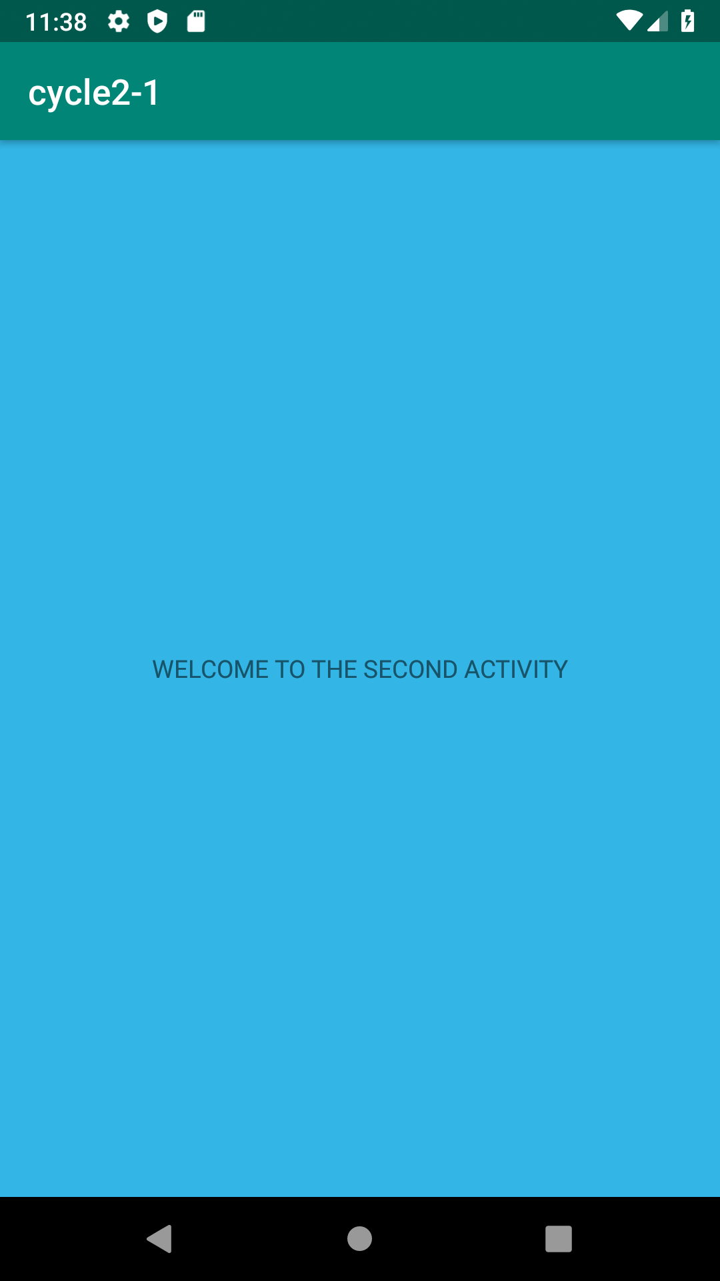

2.create an activity and move to fb loginpage on button click

**Program**

activity_main.xml

<**LinearLayout android:layout_width="match_parent" android:layout_height="match_parent"**

**android:orientation="vertical"**

**android:gravity="center"**

**xmlns:android="http://schemas.android.com/apk/res/android"**>

<**Button**

**android:layout_width="wrap_content"**

**android:layout_height="wrap_content"**

**android:text="MOVE TO FB PAGE"**

**android:id="@+id/bt"**

**android:onClick="click"**

**android:gravity="center"**/>

</**LinearLayout>**

mainActivity.java

**package** com.example.sjcet.myapplication;

**import** android.content.Intent;

**import** android.net.Uri;

**import** android.support.v7.app.AppCompatActivity;

**import** android.os.Bundle;

**import** android.view.View;

**import** android.widget.Button;

**public class** MainActivity **extends** AppCompatActivity {

@Override

**protected void** onCreate(Bundle savedInstanceState) {

**super**.onCreate(savedInstanceState);

setContentView(R.layout.***activity_main***);

Button btn_Explicit = (Button)findViewById(R.id.***bt***);

btn_Explicit.setOnClickListener(**new** View.OnClickListener() {

@Override

**public void** onClick(View view) {

Intent intent = **new** Intent(Intent.***ACTION_VIEW***,Uri.*parse*(**"https://www.facebook.com/"**));

startActivity(intent);

}

}

);

}

}

**OUTPUT**

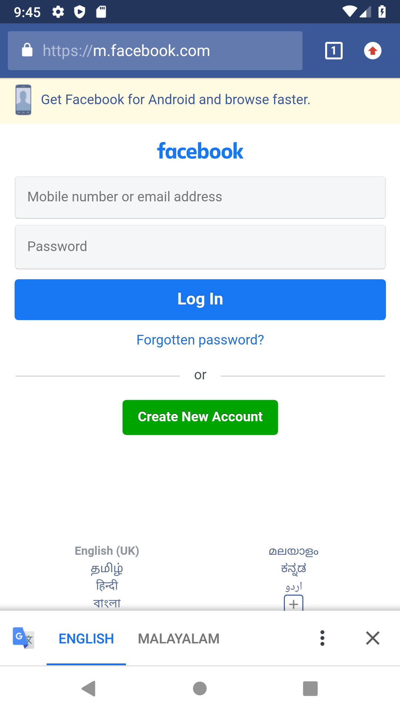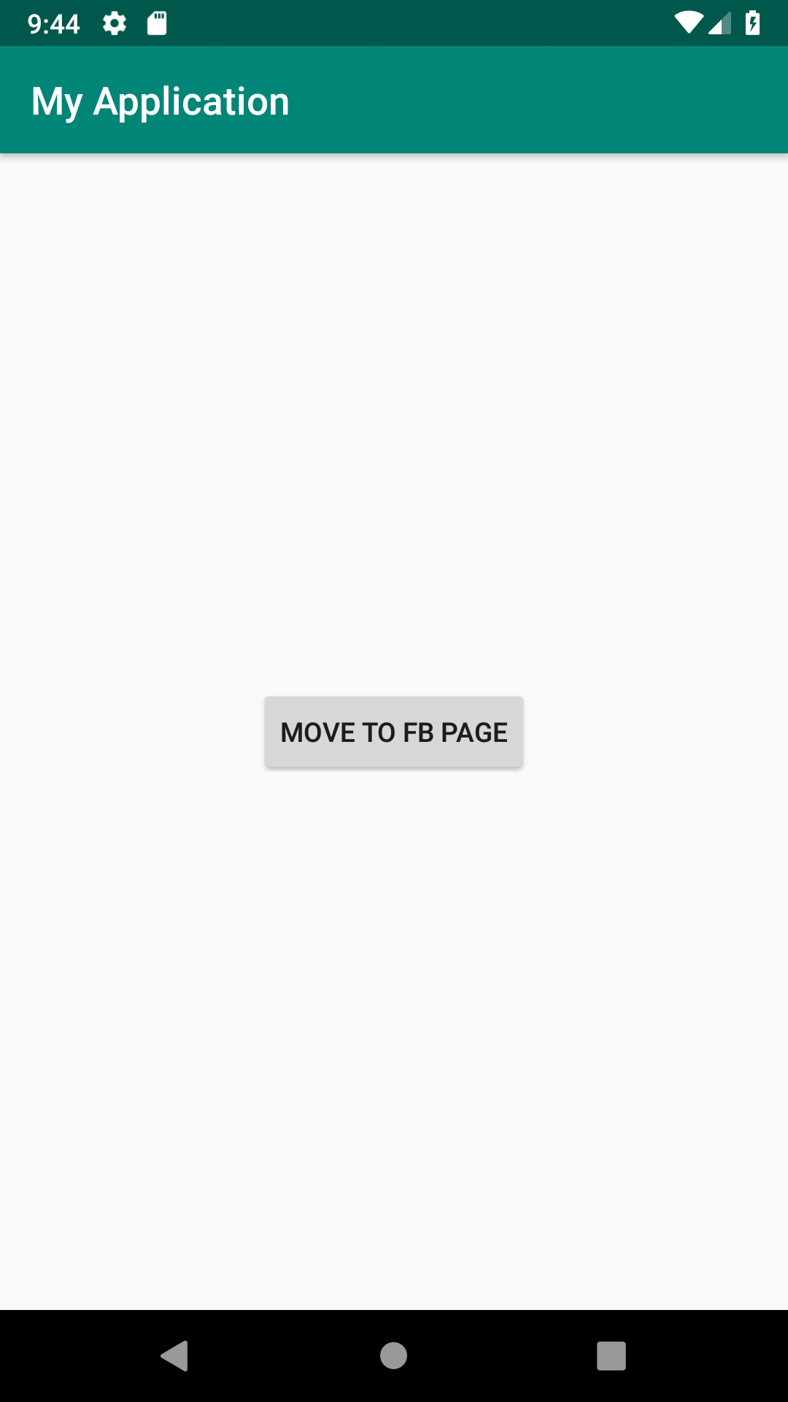

3.Read message in first activity and pass it to the second activity to the button click

**Program**

activity_main.xml

<**LinearLayout android:layout_width="match_parent" android:layout_height="match_parent"**

**android:orientation="vertical"**

**xmlns:android="http://schemas.android.com/apk/res/android"**>

<**EditText**

**android:layout_width="match_parent"**

**android:layout_height="wrap_content"**

**android:id="@+id/et"**

**android:textColor="@android:color/holo_red_dark"**/>

<**Button**

**android:layout_width="wrap_content"**

**android:layout_height="wrap_content"**

**android:text="MOVE TO NEXT ACTIVITY"**

**android:id="@+id/bt"**

**android:onClick="click"**

/>

</**LinearLayout**>

activity_main2.xml

<**LinearLayout android:layout_width="match_parent" android:layout_height="match_parent"**

**android:orientation="vertical"**

**android:gravity="center"**

**xmlns:android="http://schemas.android.com/apk/res/android"**>

<**TextView**

**android:layout_width="match_parent"**

**android:layout_height="wrap_content"**

**android:id="@+id/tv"**

/>

</**LinearLayout**>

mainActivity.java

**package** com.example.sjcet.myapplication;

**import** android.content.Intent;

**import** android.support.v7.app.AppCompatActivity;

**import** android.os.Bundle;

**import** android.view.View;

**import** android.widget.Button;

**import** android.widget.EditText;

**public class** MainActivity **extends** AppCompatActivity {

Button **bt**;

EditText **et**;

**protected void** onCreate(Bundle savedInstanceState) {

**super**.onCreate(savedInstanceState);

setContentView(R.layout.***activity_main***);

**bt** =findViewById(R.id.***bt***);

**et** =findViewById(R.id.***et***);

}

**public void** onClick(View v) {

String str = **et**.getText().toString();

Intent intent = **new** Intent(getApplicationContext(), Main2Activity.**class**);

intent.putExtra(**"message_key"**, str);

startActivity(intent);

}

}

mainActivity2.java

**package** com.example.sjcet.myapplication;

**import** android.widget.TextView;

**import** android.content.Intent;

**import** android.support.v7.app.AppCompatActivity;

**import** android.os.Bundle;

**public class** Main2Activity **extends** AppCompatActivity {

TextView **tv**;

@Override

**protected void** onCreate(Bundle savedInstanceState) {

**super**.onCreate(savedInstanceState);

setContentView(R.layout.***activity_main2***);

**tv** =findViewById(R.id.***tv***);

Intent intent = getIntent();

String str = intent.getStringExtra(**"message_key"**);

**tv**.setText(str);

}

}

**OUTPUT**

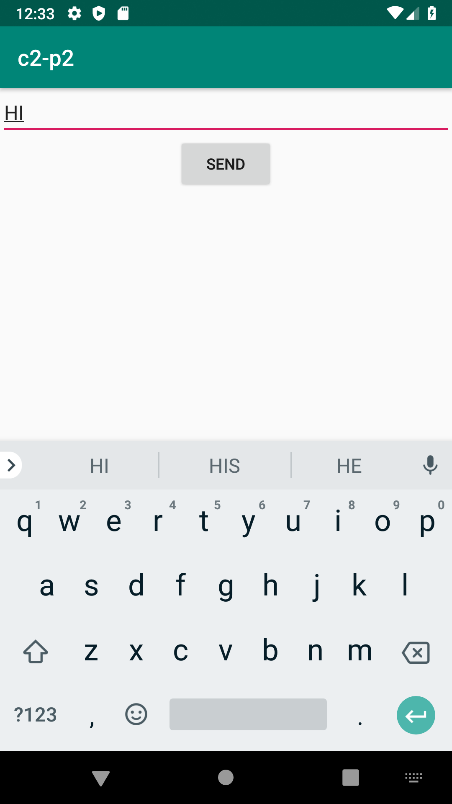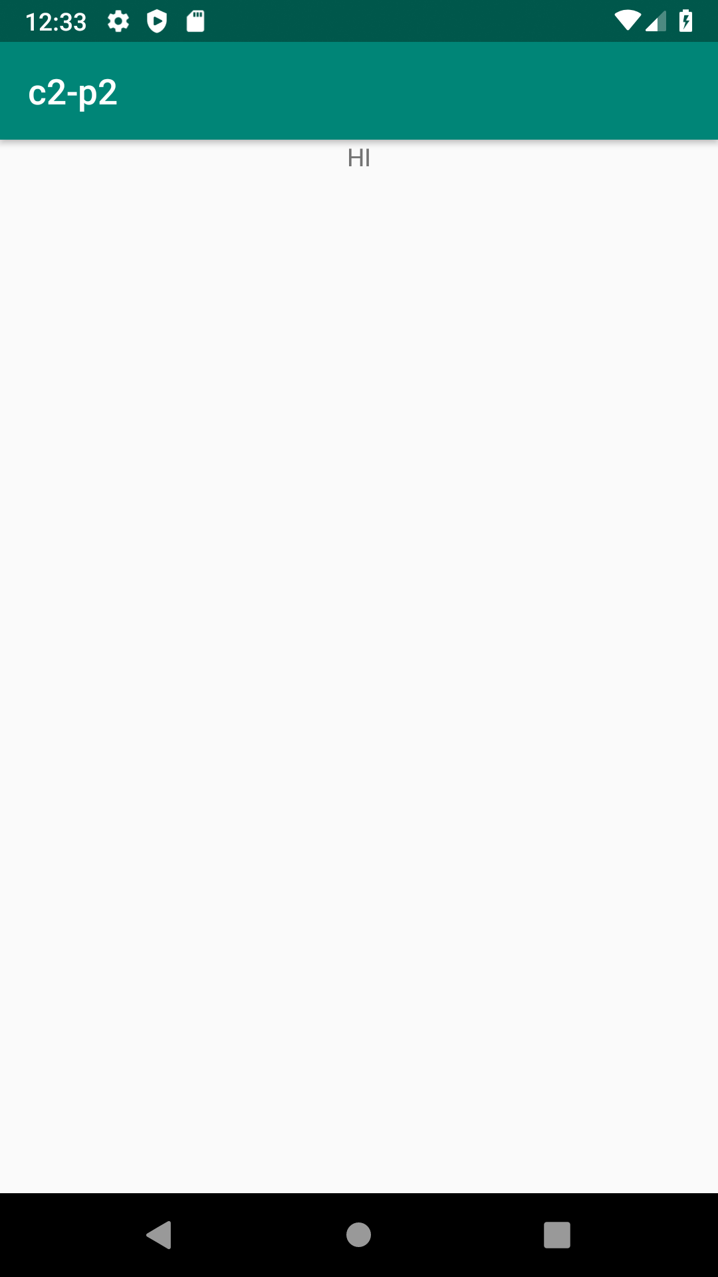

4.Create a registration page with full validation and pass the information to the second activity (using shared preference)

Mandatory fields : fname,lname,gender,email,phone number,password,dob(date picker)

**Program**

*activity_main.xml*

*<?****xml version="1.0" encoding="utf-8"****?>*

<**LinearLayout xmlns:android="http://schemas.android.com/apk/res/android"**

**xmlns:tools="http://schemas.android.com/tools"**

**android:id="@+id/activity_main"**

**android:layout_width="match_parent"**

**android:layout_height="match_parent"**

**android:orientation="vertical"**

>

<**EditText**

**android:id="@+id/editTextName"**

**android:layout_width="match_parent"**

**android:layout_height="wrap_content"**

**android:ems="10"**

**android:hint="Enter First Name"**

**android:inputType="textPersonName"** />

<**EditText**

**android:id="@+id/editTextlName"**

**android:layout_width="match_parent"**

**android:layout_height="wrap_content"**

**android:ems="10"**

**android:hint="Enter Last Name"**

**android:inputType="textPersonName"** />

<**EditText**

**android:id="@+id/editTextgender"**

**android:layout_width="match_parent"**

**android:layout_height="wrap_content"**

**android:ems="10"**

**android:hint="Enter Gender"**

**android:inputType="textPersonName"** />

<**EditText**

**android:id="@+id/editTextEmail"**

**android:layout_width="match_parent"**

**android:layout_height="wrap_content"**

**android:ems="10"**

**android:hint="Enter Email"**

**android:inputType="textPersonName"** />

<**EditText**

**android:id="@+id/editTextMobile"**

**android:layout_width="match_parent"**

**android:layout_height="wrap_content"**

**android:ems="10"**

**android:hint="Enter Mobile Number"**

**android:inputType="textEmailAddress"** />

<**EditText**

**android:id="@+id/editTextDob"**

**android:layout_width="match_parent"**

**android:layout_height="wrap_content"**

**android:ems="10"**

**android:hint="Enter Date of Birth (DD/MM/YYYY)"**

**android:inputType="date"** />

<**EditText**

**android:id="@+id/editTextpassword"**

**android:layout_width="match_parent"**

**android:layout_height="wrap_content"**

**android:ems="10"**

**android:hint="Enter Password"**

**android:inputType="textPassword"** />

<**Button**

**android:id="@+id/buttonSubmit"**

**android:layout_width="match_parent"**

**android:layout_height="wrap_content"**

**android:text="Submit"** />

</**LinearLayout**>

*Mainactivity.java*

***package*** *com.example.sjcet.myapplication;*

**import** android.content.Intent;

**import** android.net.Uri;

**import** android.support.v7.app.AppCompatActivity;

**import** android.os.Bundle;

**import** android.text.TextUtils;

**import** android.util.Patterns;

**import** android.view.View;

**import** android.widget.DatePicker;

**import** android.widget.EditText;

**import** android.widget.Button;

**import** android.widget.Toast;

**import** android.content.SharedPreferences;

**public class** MainActivity **extends** AppCompatActivity {

EditText **editTextName**, **editTextlName**,**editTextEmail**, **editTextMobile**,

**editTextDob**, **editTextgender**,**editTextpassword**;

Button **buttonSubmit**;

@Override

**protected void** onCreate(Bundle savedInstanceState) {

**super**.onCreate(savedInstanceState);

setContentView(R.layout.***activity_main***);

**buttonSubmit** =findViewById(R.id.***buttonSubmit***);

**editTextName** =findViewById(R.id.***editTextName***);

**editTextlName** =findViewById(R.id.***editTextlName***);

**editTextEmail** =findViewById(R.id.***editTextEmail***);

**editTextMobile** =findViewById(R.id.***editTextMobile***);

**editTextDob** =findViewById(R.id.***editTextDob***);

**editTextgender** =findViewById(R.id.***editTextgender***);

**editTextpassword** =findViewById(R.id.***editTextpassword***);

**buttonSubmit**.setOnClickListener(**new** View.OnClickListener() {

@Override

**public void** onClick(View view) {

checkDataEntered();

SharedPreferences mypref=getSharedPreferences(**"activity_main2.xml"**,0);

SharedPreferences.Editor editor=mypref.edit();*//only write editor*

editor.putString(**"fname"**,**editTextName**.getText().toString()); *//bundle the data*

editor.putString(**"lname"**,**editTextlName**.getText().toString());

editor.putString(**"gender"**,**editTextgender**.getText().toString());

editor.putString(**"phone"**,**editTextMobile**.getText().toString());

editor.putString(**"pwd"**,**editTextpassword**.getText().toString());

editor.putString(**"email"**,**editTextEmail**.getText().toString());

editor.putString(**"dob"**,**editTextDob**.getText().toString());

editor.commit();

Intent intent = **new** Intent(getApplicationContext(), Main2Activity.**class**);

intent.putExtra(**"fname"**,**editTextName**.getText().toString());

intent.putExtra(**"lname"**,**editTextlName**.getText().toString());

intent.putExtra(**"gender"**,**editTextgender**.getText().toString());

intent.putExtra(**"phone"**,**editTextMobile**.getText().toString());

intent.putExtra(**"pwd"**,**editTextpassword**.getText().toString());

intent.putExtra(**"email"**,**editTextEmail**.getText().toString());

intent.putExtra(**"dob"**,**editTextDob**.getText().toString());

startActivity(intent);

}

});

}

**boolean** isEmail(EditText text) {

CharSequence email = text.getText().toString();

**return** (!TextUtils.*isEmpty*(email) && Patterns.***EMAIL_ADDRESS***.matcher(email).matches());

}

**boolean** isEmpty(EditText text) {

CharSequence str = text.getText().toString();

**return** TextUtils.*isEmpty*(str);

}

**void** checkDataEntered() {

**if** (isEmpty(**editTextName**)) {

Toast t = Toast.*makeText*(**this**, **"You must enter first name to register!"**, Toast.***LENGTH_SHORT***);

t.show();

}

**if** (isEmpty(**editTextlName**)) {

**editTextlName**.setError(**"Last name is required!"**);

}

**if** (isEmpty(**editTextMobile**)) {

**editTextMobile**.setError(**"mobile number is required!"**);

}

**if** (isEmpty(**editTextgender**)) {

**editTextgender**.setError(**"Gender is required!"**);

}

**if** (isEmpty(**editTextpassword**)) {

**editTextpassword**.setError(**"Password is required!"**);

}

**if** (isEmpty(**editTextDob**)) {

**editTextDob**.setError(**"DOB is required!"**);

}

**if** (isEmail(**editTextEmail**) == **false**) {

**editTextEmail**.setError(**"Enter valid email!"**);

}

}

}

*activity_main2.xml*

*<****LinearLayout android:layout_width="match_parent" android:layout_height="match_parent"***

**android:orientation="vertical"**

**android:gravity="center"**

**xmlns:android="http://schemas.android.com/apk/res/android"**>

<**TextView**

**android:layout_width="match_parent"**

**android:layout_height="wrap_content"**

**android:id="@+id/tv"**

/>

<**TextView**

**android:layout_width="match_parent"**

**android:layout_height="wrap_content"**

**android:id="@+id/tv1"**

/>

<**TextView**

**android:layout_width="match_parent"**

**android:layout_height="wrap_content"**

**android:id="@+id/tv2"**

/>

<**TextView**

**android:layout_width="match_parent"**

**android:layout_height="wrap_content"**

**android:id="@+id/tv3"**

/>

<**TextView**

**android:layout_width="match_parent"**

**android:layout_height="wrap_content"**

**android:id="@+id/tv4"**

/>

<**TextView**

**android:layout_width="match_parent"**

**android:layout_height="wrap_content"**

**android:id="@+id/tv5"**

/>

<**TextView**

**android:layout_width="match_parent"**

**android:layout_height="wrap_content"**

**android:id="@+id/tv6"**

/>

</**LinearLayout**>

*mainActivity2.java*

***package*** *com.example.sjcet.myapplication;*

**import** android.content.SharedPreferences;

**import** android.widget.TextView;

**import** android.content.Intent;

**import** android.support.v7.app.AppCompatActivity;

**import** android.os.Bundle;

**public class** Main2Activity **extends** AppCompatActivity {

TextView **tv**,**tv1**,**tv2**,**tv3**,**tv4**,**tv5**,**tv6**;

@Override

**protected void** onCreate(Bundle savedInstanceState) {

**super**.onCreate(savedInstanceState);

setContentView(R.layout.***activity_main2***);

**tv** =findViewById(R.id.***tv***);

**tv1** =findViewById(R.id.***tv1***);

**tv2** =findViewById(R.id.***tv2***);

**tv3** =findViewById(R.id.***tv3***);

**tv4** =findViewById(R.id.***tv4***);

**tv5** =findViewById(R.id.***tv5***);

**tv6** =findViewById(R.id.***tv6***);

Intent intent = getIntent();

SharedPreferences mypref=getSharedPreferences(**"activity_main2.xml"**,0);

String str = mypref.getString(**"fname"**,**null**);

String str1 = mypref.getString(**"lname"**,**null**);

String str2 = mypref.getString(**"gender"**,**null**);

String str3 = mypref.getString(**"phone"**,**null**);

String str4 = mypref.getString(**"pwd"**,**null**);

String str5 = mypref.getString(**"email"**,**null**);

String str6 = mypref.getString(**"dob"**,**null**);

**tv**.setText(str);

**tv1**.setText(str1);

**tv2**.setText(str2);

**tv3**.setText(str3);

**tv4**.setText(str4);

**tv5**.setText(str5);

**tv6**.setText(str6);

}

}

***Output***

